# Pie chart in ggplot2

## Sample data

The following data frame contains a numerical variable representing the count of some event and the corresponding label for each value.

df <- **data.frame**(value = **c**(10, 23, 15, 18), group = **paste0**(**"G"**, 1:4))

|  |  |
| --- | --- |
| value | group |
| 10 | G1 |
| 23 | G2 |
| 15 | G3 |
| 18 | G4 |

## Basic pie chart with geom_bar or geom_col and coord_polar

### Basic pie chart

A pie chart in ggplot is a bar plot plus a polar coordinate. You can use geom_bar or geom_col and theta = "y" inside coord_polar.

# install.packages("ggplot2")

**library**(ggplot2)

**ggplot**(df, **aes**(x = **""**, y = value, fill = group)) +

**geom_col**() +

**coord_polar**(theta = **"y"**)

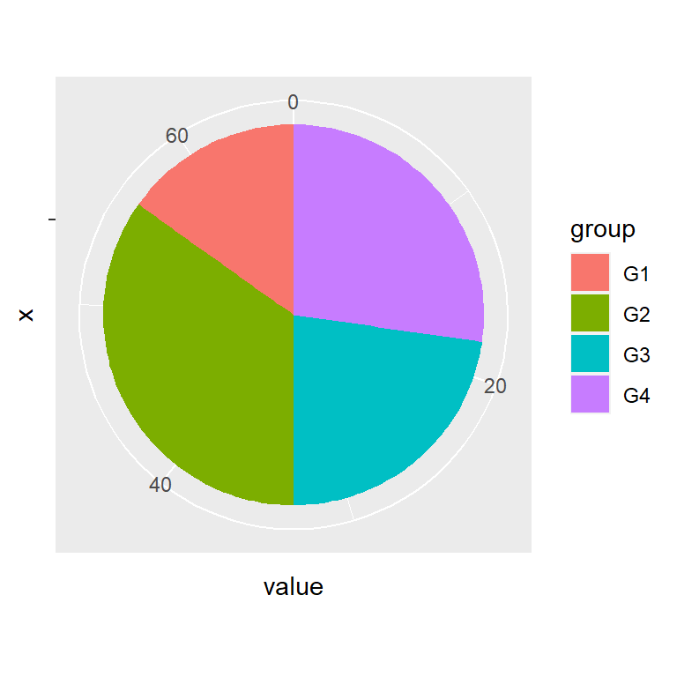

## Color of the lines

The borders of the pie can be changed with the color argument of the geom_bar or geom_col function.

# install.packages("ggplot2")

**library**(ggplot2)

**ggplot**(df, **aes**(x = **""**, y = value, fill = group)) +

**geom_col**(color = **"black"**) +

**coord_polar**(theta = **"y"**)

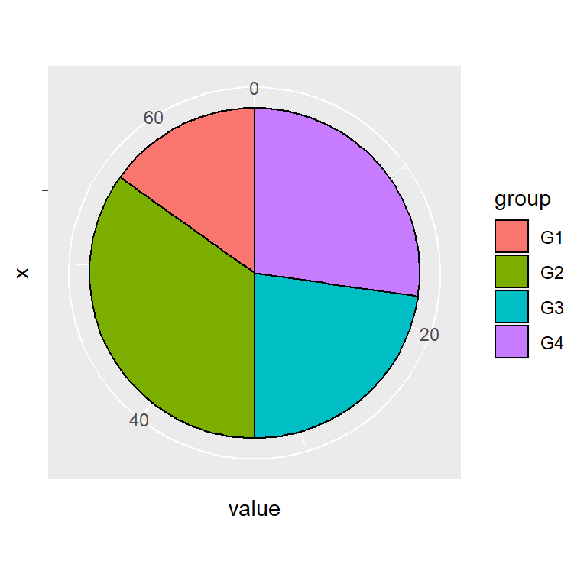

## Text and labels

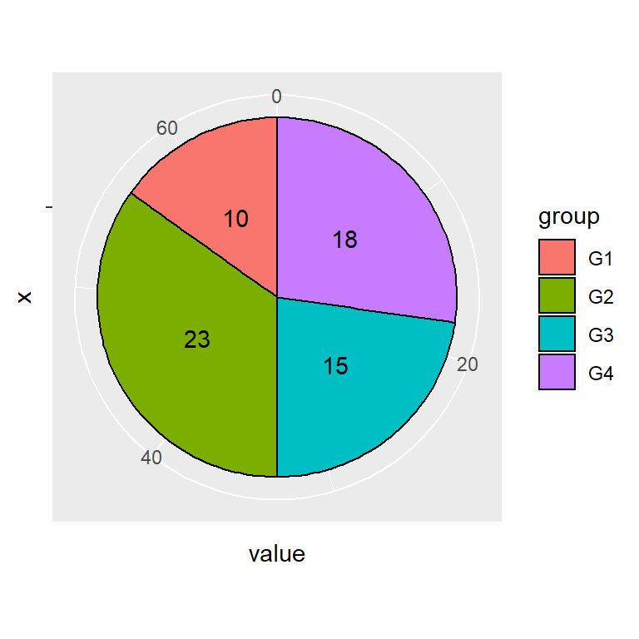

## Adding text

By default, the values are not displayed inside each slice. You can add them with geom_text. Note that position_stack(vjust = 0.5) will place the labels in the correct position.

# install.packages("ggplot2")

**library**(ggplot2)

**ggplot**(df, **aes**(x = **""**, y = value, fill = group)) +

**geom_col**(color = **"black"**) +

**geom_text**(**aes**(label = value),

position = **position_stack**(vjust = 0.5)) +

**coord_polar**(theta = **"y"**)

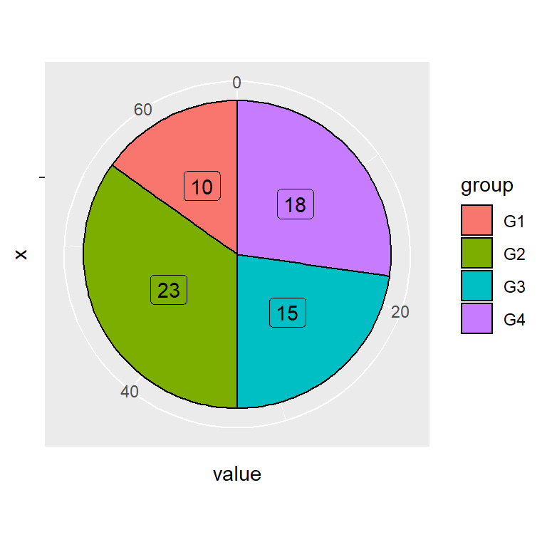

## Adding labels

An alternative to geom_text is using geom_label, which adds a border around the values. If you set this the legend will display the letter “a” inside the boxes, so we have overridden this behavior with show.legend = FALSE.

# install.packages("ggplot2")

**library**(ggplot2)

**ggplot**(df, **aes**(x = **""**, y = value, fill = group)) +

**geom_col**(color = **"black"**) +

**geom_label**(**aes**(label = value),

position = **position_stack**(vjust = 0.5),

show.legend = FALSE) +

**coord_polar**(theta = **"y"**)

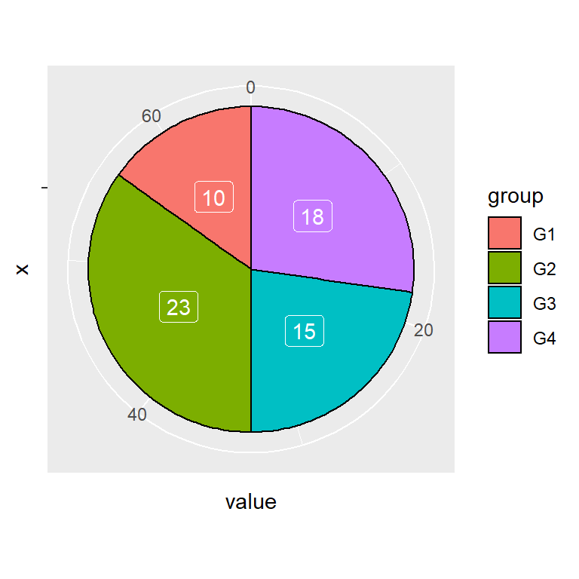

## Labels color

Note that you can change the color of the labels with color.

# install.packages("ggplot2")

**library**(ggplot2)

**ggplot**(df, **aes**(x = **""**, y = value, fill = group)) +

**geom_col**(color = **"black"**) +

**geom_label**(**aes**(label = value),

color = **"white"**,

position = **position_stack**(vjust = 0.5),

show.legend = FALSE) +

**coord_polar**(theta = **"y"**)

### Color customization

## Color palette

The default color palette can be changed with a predefined color palette, such as the scale_fill_brewer or scale_fill_viridis_d.

# install.packages("ggplot2")

**library**(ggplot2)

**ggplot**(df, **aes**(x = **""**, y = value, fill = group)) +

**geom_col**(color = **"black"**) +

**geom_text**(**aes**(label = value),

position = **position_stack**(vjust = 0.5)) +

**coord_polar**(theta = **"y"**) +

**scale_fill_brewer**()

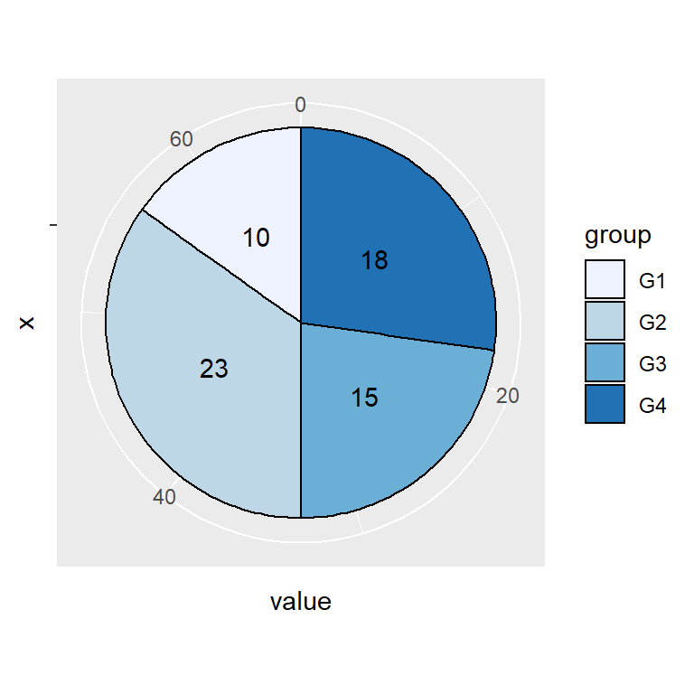

## Custom colors

If you prefer setting your own colors you can make use of scale_fill_manual and set the corresponding colors.

# install.packages("ggplot2")

**library**(ggplot2)

**ggplot**(df, **aes**(x = **""**, y = value, fill = group)) +

**geom_col**(color = **"black"**) +

**geom_text**(**aes**(label = value),

position = **position_stack**(vjust = 0.5)) +

**coord_polar**(theta = **"y"**) +

**scale_fill_manual**(values = **c**(**"#BE2A3E"**, **"#EC754A"**,

**"#EACF65"**, **"#3C8D53"**))

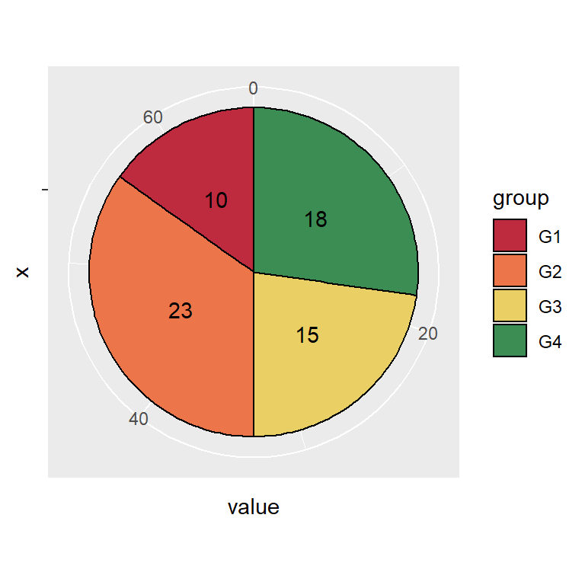

## Theme customization

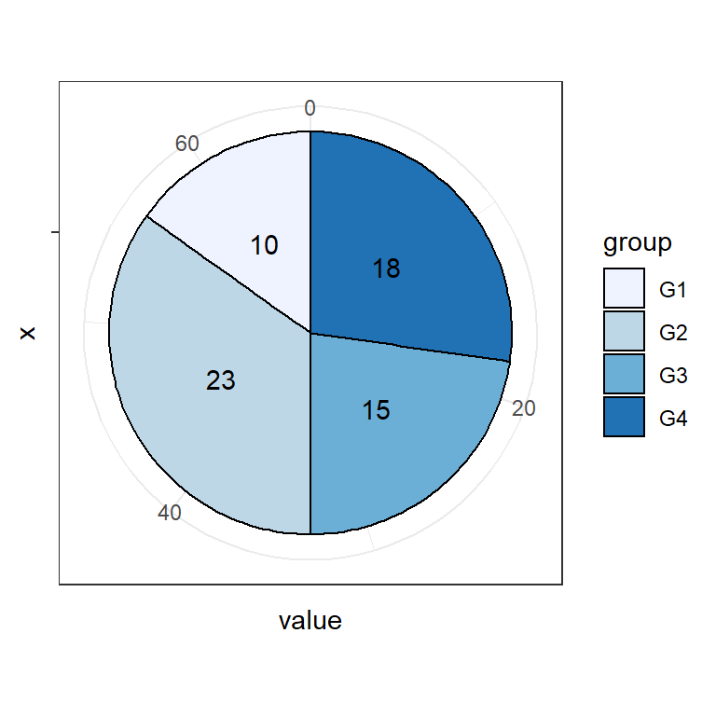

The default pie chart styling can be changed in ggplot2 making use of themes.

# install.packages("ggplot2")

**library**(ggplot2)

**ggplot**(df, **aes**(x = **""**, y = value, fill = group)) +

**geom_col**(color = **"black"**) +

**geom_text**(**aes**(label = value),

position = **position_stack**(vjust = 0.5)) +

**coord_polar**(theta = **"y"**) +

**scale_fill_brewer**() +

**theme_bw**()

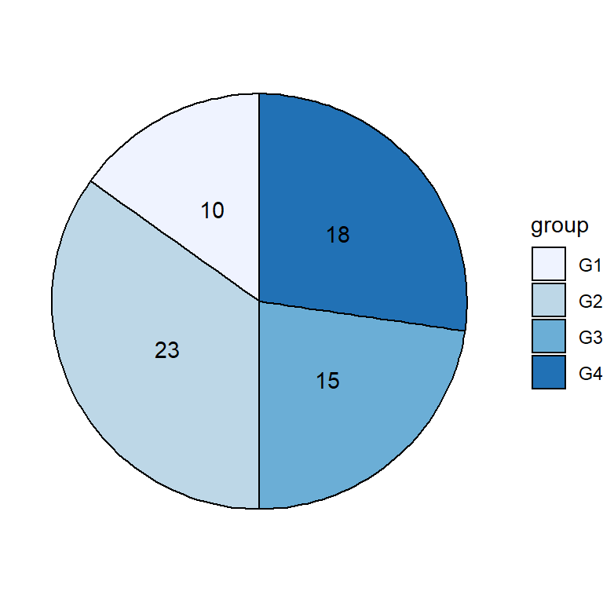

You can also remove the whole theme with theme_void.

# install.packages("ggplot2")

**library**(ggplot2)

**ggplot**(df, **aes**(x = **""**, y = value, fill = group)) +

**geom_col**(color = **"black"**) +

**geom_text**(**aes**(label = value),

position = **position_stack**(vjust = 0.5)) +

**coord_polar**(theta = **"y"**) +

**scale_fill_brewer**() +

**theme_void**()

You can get a customized style customizing the theme components. Note that you can create your custom theme if you want to reproduce the styling.

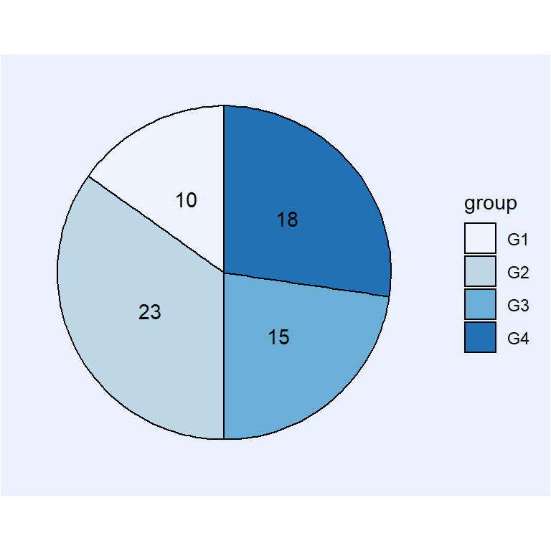

# install.packages("ggplot2")

**library**(ggplot2)

**ggplot**(df, **aes**(x = **""**, y = value, fill = group)) +

**geom_col**(color = **"black"**) +

**geom_text**(**aes**(label = value),

position = **position_stack**(vjust = 0.5)) +

**coord_polar**(theta = **"y"**) +

**scale_fill_brewer**() +

**theme**(axis.text = **element_blank**(),

axis.ticks = **element_blank**(),

axis.title = **element_blank**(),

panel.grid = **element_blank**(),

panel.background = **element_rect**(fill = **"#ebf2ff"**),

plot.background = **element_rect**(fill = **"#ebf2ff"**),

legend.background = **element_rect**(fill = **"#ebf2ff"**))

## Legend customization

## Legend title

The default legend title is the name of the categorical variable of the input data frame. Change it following the example below.

# install.packages("ggplot2")

**library**(ggplot2)

**ggplot**(df, **aes**(x = **""**, y = value, fill = group)) +

**geom_col**(color = **"black"**) +

**geom_text**(**aes**(label = value),

position = **position_stack**(vjust = 0.5)) +

**coord_polar**(theta = **"y"**) +

**guides**(fill = **guide_legend**(title = **"Title"**))

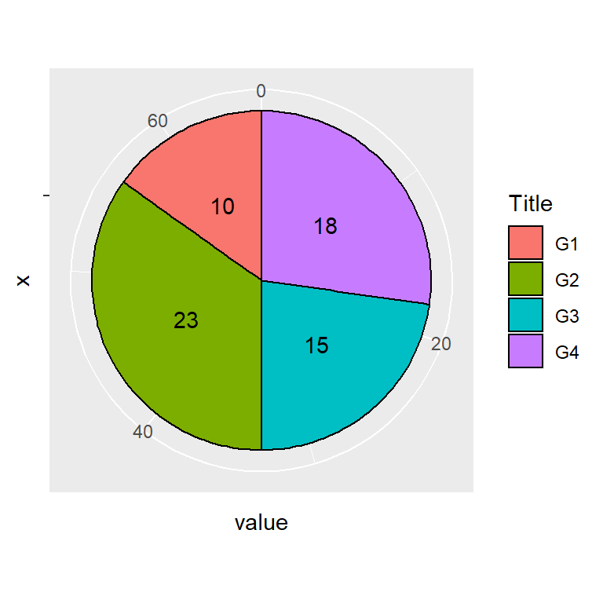

## Legend labels

The labels of the lagend can also be modified. Use the labels argument of scale_fill_discrete or scale_fill_manual.

# install.packages("ggplot2")

**library**(ggplot2)

**ggplot**(df, **aes**(x = **""**, y = value, fill = group)) +

**geom_col**(color = **"black"**) +

**geom_text**(**aes**(label = value),

position = **position_stack**(vjust = 0.5)) +

**coord_polar**(theta = **"y"**) +

**scale_fill_discrete**(labels = **c**(**"A"**, **"B"**, **"C"**, **"D"**))

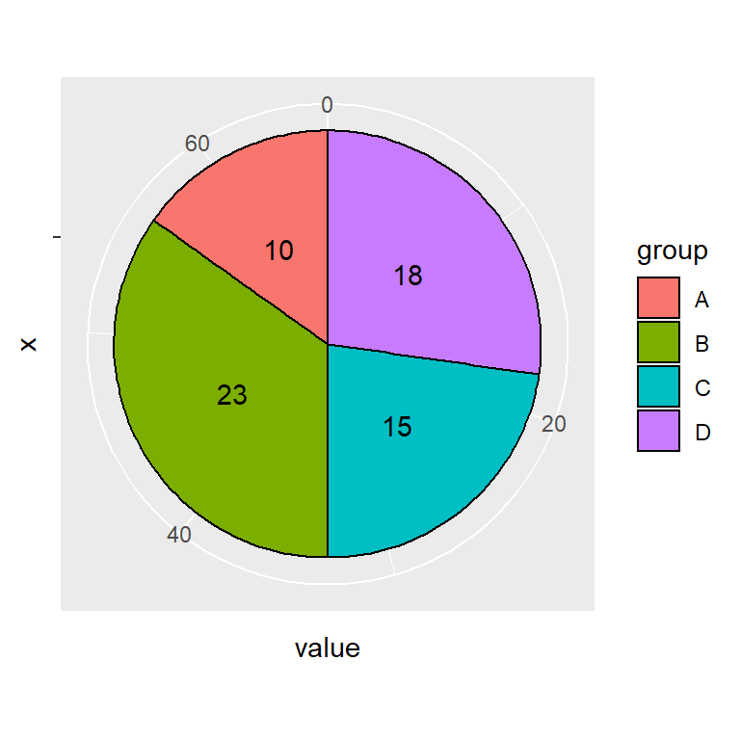

## Legend position

The legend can be placed in several positions with the legend.position component of the theme function. Possible placement values are "bottom", "left", "top" and "right" (default).

# install.packages("ggplot2")

**library**(ggplot2)

**ggplot**(df, **aes**(x = **""**, y = value, fill = group)) +

**geom_col**(color = **"black"**) +

**geom_text**(**aes**(label = value),

position = **position_stack**(vjust = 0.5)) +

**coord_polar**(theta = **"y"**) +

**theme**(legend.position = **"bottom"**)

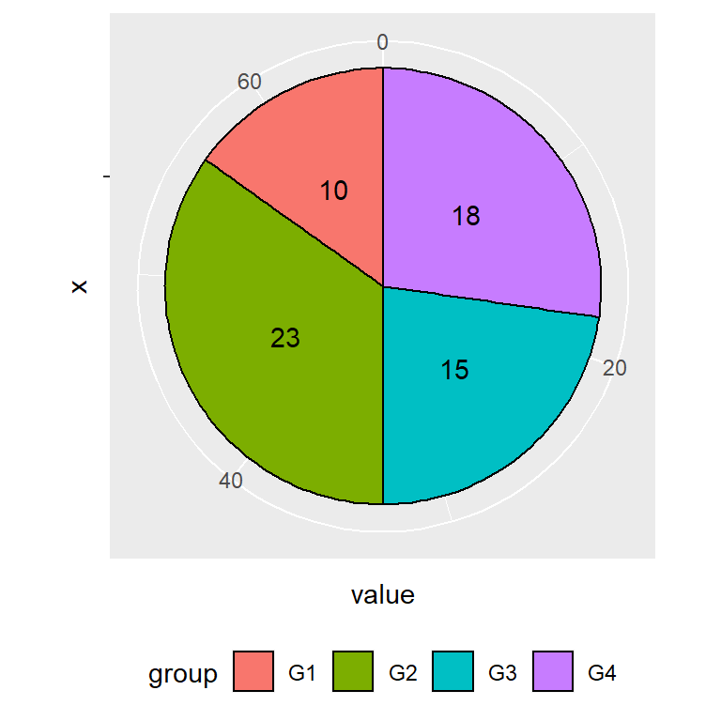

## Remove the legend

If you prefer removing the legend set the position component to "none".

# install.packages("ggplot2")

**library**(ggplot2)

**ggplot**(df, **aes**(x = **""**, y = value, fill = group)) +

**geom_col**(color = **"black"**) +

**geom_text**(**aes**(label = value),

position = **position_stack**(vjust = 0.5)) +

**coord_polar**(theta = **"y"**) +

**theme**(legend.position = **"none"**)